**HAAR CASCADE CLASSIFIER**

**Description of the Problem**

Our project addresses the challenge of recognizing and detecting human facial features, specifically smiles and eyes, using computer vision techniques. In today’s world, facial detection and recognition technologies play a vital role in various fields like security, healthcare, and entertainment. The ability to identify smiles and eyes has applications in:

* **Emotion Detection**: Determining a person's mood or emotional state based on their facial expressions.
* **Authentication Systems**: Enhancing biometric systems by incorporating facial feature recognition for better accuracy.
* **Interactive Applications**: Developing applications that respond to user emotions, such as games or virtual assistants.

The target outcome of this project is to create a functional system using Haarcascade classifiers that can efficiently detect smiles and eyes in real-time. This system can be integrated into larger applications or used as a standalone tool for research and educational purposes.

**Why We Selected This Problem**

We chose this problem due to its relevance and growing demand in the field of artificial intelligence and computer vision. Detecting smiles and eyes has significant practical implications:

1. **Real-World Applications**:
   * **Healthcare**: In mental health assessments, monitoring a patient’s facial expressions, like smiles, can provide insights into their emotional well-being.
   * **Customer Experience**: Businesses can use smile detection to measure customer satisfaction during interactions.
   * **Safety Features**: Eye detection can help in developing driver fatigue monitoring systems to reduce accidents.
2. **Personal Motivation**:
   * **Learning Opportunity**: Implementing a real-time detection system is an excellent way to learn and understand computer vision concepts.
   * **Creative Potential**: Building this system opens opportunities for creating engaging and innovative applications that interact with users.

**Example of Real-Life Applications**

* **Security Systems**: Many modern security systems use face and eye recognition to grant access. Adding smile detection could improve the process by identifying suspicious behavior.
* **Virtual Photobooths**: Smile detection is often used in cameras to automatically take pictures when a person smiles, making the experience user-friendly and enjoyable.
* **Driver Monitoring Systems**: Eye detection is a critical feature in systems designed to monitor driver alertness, ensuring safer driving by detecting signs of drowsiness.

**CASCADE CLASSIFIER:-**

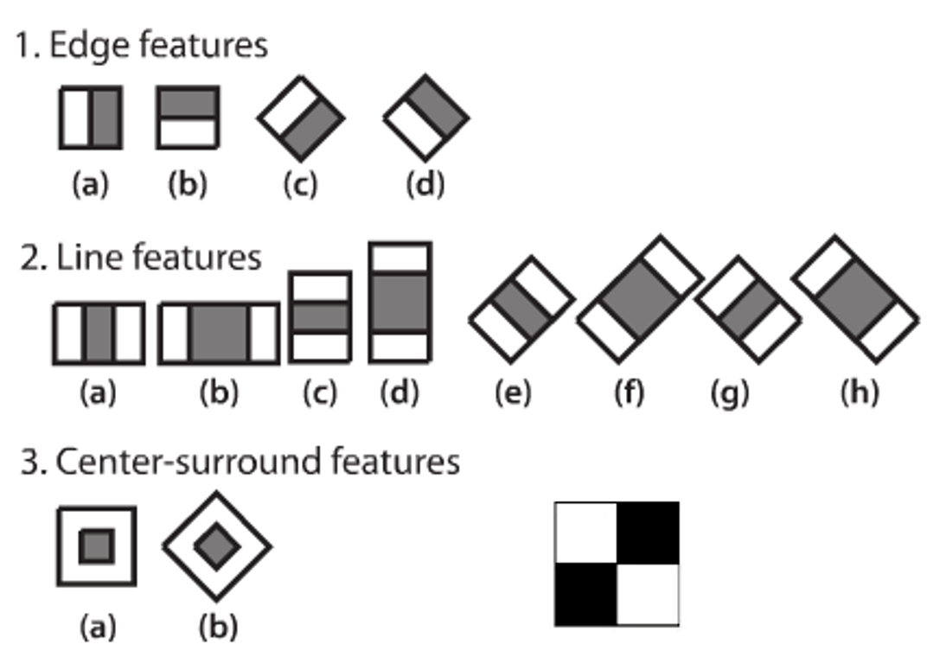

**Methadology**

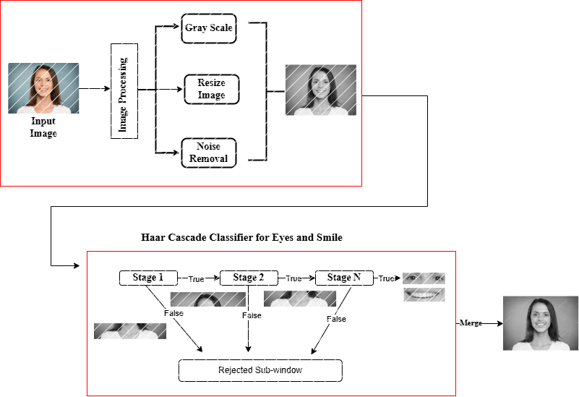  
  
**What are Har Features**

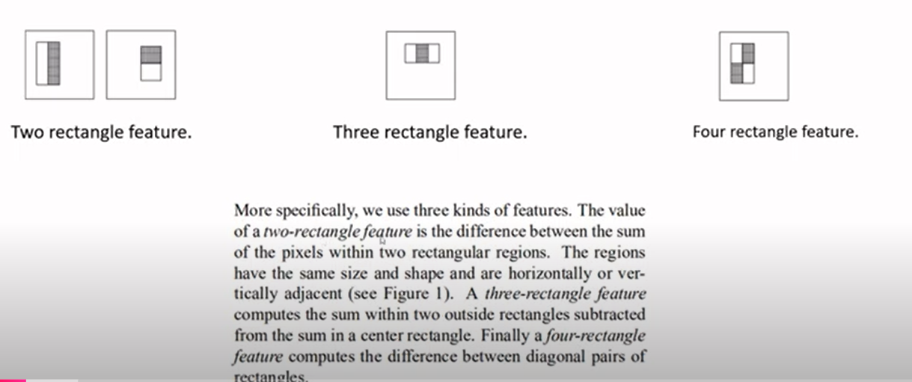

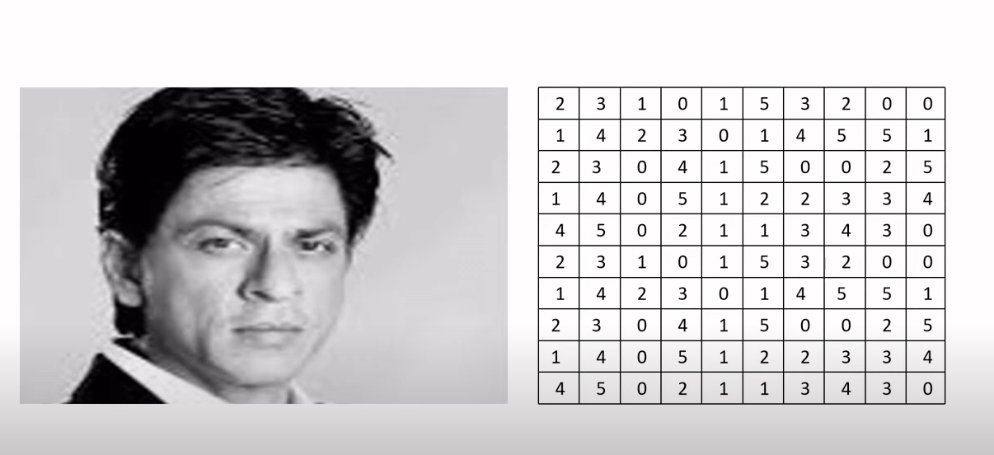

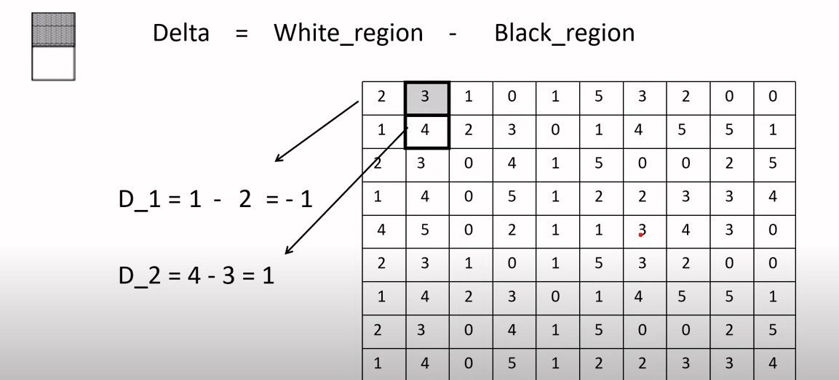

This image illustrates how the Haar-like features are calculated for image regions. It focuses on the difference (Delta) between two regions: the white region and the black region, which are part of a rectangular filter used in Haar cascade classifiers. Here's a step-by-step explanation:

1. **Delta Calculation:**
   * This measures the intensity difference between the white and black regions in the image, which is a key feature for identifying patterns like edges, lines, or specific shapes.
2. **Example in the Grid:**
   * Each cell in the grid represents pixel intensity values.
   * Two specific examples are highlighted:
     + D1: For the top-left rectangle, the sum of pixel values in the white region is 1, and in the black region, it is 2. The delta (D1D_1D1​) is calculated as 1−2=−11 - 2 = -11−2=−1.
     + D2: For another rectangle, the white region's sum is 4, and the black region's sum is 3. The delta (D2D_2D2​) is calculated as 4−3=14 - 3 = 14−3=1.
3. **Purpose**:
   * This process helps detect features in the image. For example:
     + A large positive or negative delta indicates a significant difference in intensities, which might correspond to an edge or corner.
     + These deltas are used by machine learning algorithms to classify objects like smiles, eyes, or other features in facial detection.

This concept is central to Haarcascade's functionality, as it enables efficient and fast detection of visual features in an image.

**How are They Useful**

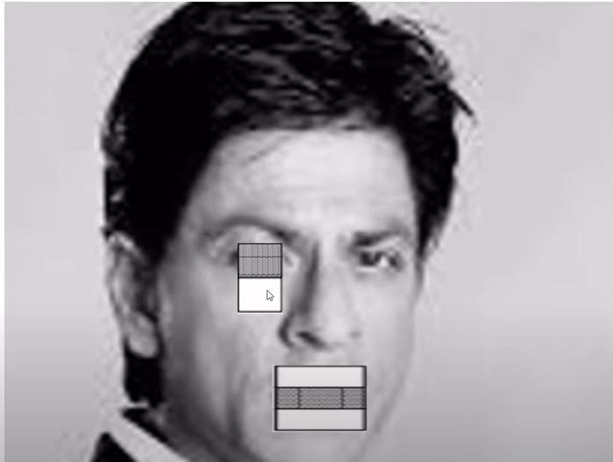

This image demonstrates how Haar-like features are applied to detect facial features such as eyes and mouth in a human face. Here's an easy-to-understand explanation:

1. **Haar-Like Feature Rectangles:**
   * Two rectangular regions are shown on the face:
     + Around the eye: A small Haar-like filter is used to analyze the contrast between the upper and lower parts of the region. This helps identify the structure of an eye (e.g., the darker area of the eye versus the lighter area around it).
     + Around the mouth: A larger Haar-like filter is applied, comparing the contrast between the upper and lower parts of the mouth. This is useful for detecting the shape and position of a smile or lips.
2. **How It Works:**
   * The filters (white and black regions) are used to compute the difference in pixel intensities. For example:
     + In the eye region, the filter detects dark pixels (inside the eye) versus lighter pixels (skin around the eye).
     + In the mouth region, the filter identifies the darker area (the mouth opening) compared to lighter surrounding regions.
   * These differences help the algorithm identify specific features like eyes and mouths, even in grayscale images.

**TYPES AND THEIR IMPORTANCE**

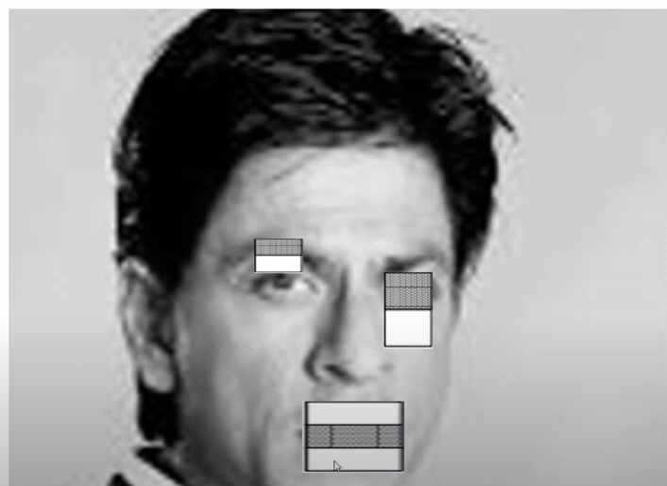 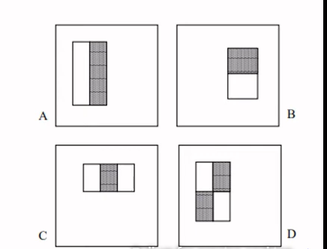

**. Types of Haar-like Features**

The right side of the image shows four common types of Haar-like features labeled A, B, C, and D:

* **A (Two-rectangle feature)**: Compares two adjacent regions. It detects vertical changes in intensity, useful for identifying edges (e.g., boundary between the forehead and hair).
* **B (Two-rectangle feature)**: Similar to A, but compares horizontal regions. This is effective for detecting horizontal patterns like the separation between the lips and skin.
* **C (Three-rectangle feature)**: Compares three regions—two light and one dark (or vice versa). This can detect fine-grained patterns like the bridge of the nose.
* **D (Four-rectangle feature)**: Compares four rectangular regions. This detects complex intensity patterns, useful for distinguishing detailed structures like corners or cross patterns (e.g., eye corners).